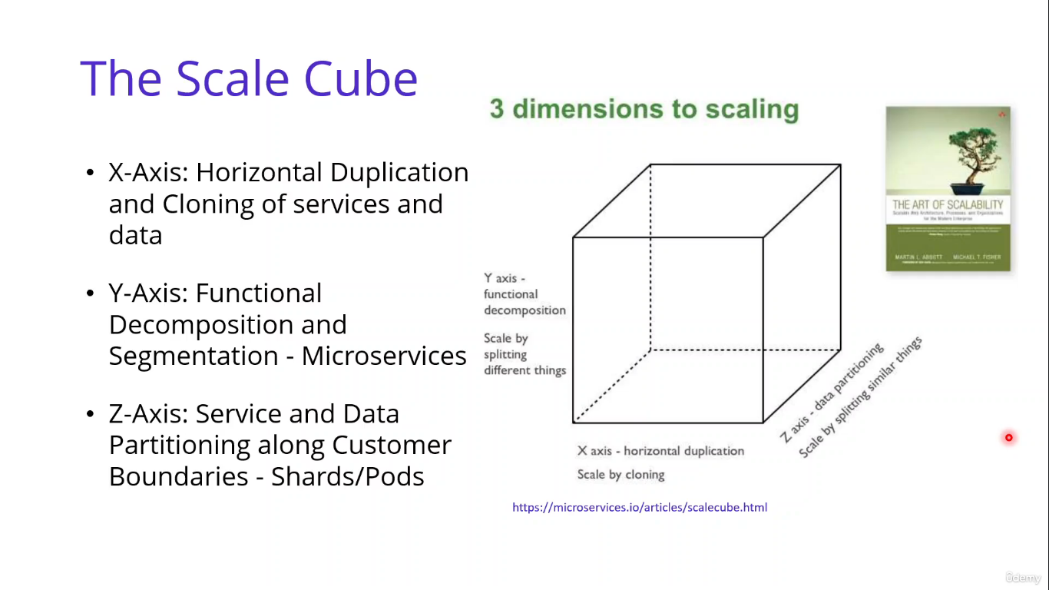

Monolithic Architecture here X-Axis and MS Architecture- Message Broker is Y-Axis in Cube

